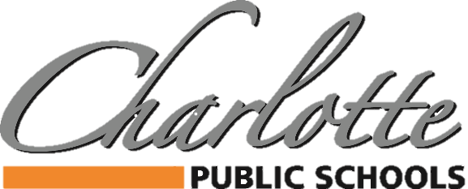

378 State Street, Charlotte, MI 48813 PH: 517.541.5100 FAX: 517.541.5105

BUDGET AND SALARY/COMPENSATION TRANSPARENCY REPORT
DISTRICT PAID ASSOCIATION DUES/MEMBERSHIP
2023-2024

ASSOCIATION | AMOUNT |  | ASSOCIATION | AMOUNT
BUSINESS PROFESSIONALS OF AMERICA | $662 |  | COMP CHEER COACHES OF MI | $115
CAPITAL AREA ACTIVITIES CONFERENCE | $3,250 |  | MSBOA | $750
CHARLOTTE CHAMBER OF COMMERCE | $700 |  | MISCA | $50
CHARLOTTE ROTARY CLUB | $1,175 |  | MECA | $75
HPS | $3,275 |  | MHSIBCA | $80
MASB | $5,479 |  | BCAM | $82
MASSP | $1,400 |  | MWA | $405
MHSAA | $30 |  | INGHAM ISD | $10,986
MIAAA | $155 |  | GFOA | $280
MASA | $1,385 |  | CMSBO (INGHAM ISD) | $170
MSBO/MAPT/ASBO | $1,815
MIHSSCA | $60
PROJECT LEAD THE WAY | $3,200
MI FITNESS FOUNDATION | $102
MAAE | $1,300
MAASE | $300
GREATER LANSING CVB | $125
MEMSPA | $320

