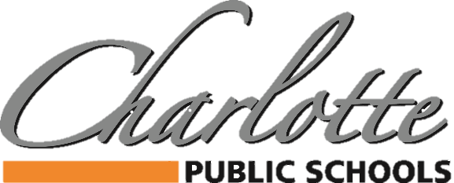

378 State Street, Charlotte, MI 48813 PH: 517.541.5100 FAX: 517.541.5105

BUDGET AND SALARY/COMPENSATION TRANSPARENCY REPORT
DISTRICT PAID ASSOCIATION DUES/MEMBERSHIP
2024-2025

ASSOCIATION | AMOUNT |  | ASSOCIATION | AMOUNT
BUSINESS PROFESSIONALS OF AMERICA | $450 |  | COMP CHEER COACHES OF MI | $200
CAPITAL AREA ACTIVITIES CONFERENCE | $3,275 |  | BCAM | $90
CHARLOTTE CHAMBER OF COMMERCE | $700 |  | MECA | $75
CHARLOTTE ROTARY CLUB | $403 |  | MWA | $105
HPS | $3,275 |  | MEMSPA | $320
MASB | $5,638 |  | MSVMA | $770
MASSP | $1,625
MHSIBCA | $80 |  | INGHAM ISD (REMC 13) | $7,351
MIAAA | $161
MASA | $1,385 |  | CMSBO (INGHAM ISD) | $255
MI BUSINESS EDUCATION ASSOCIATION | $290 |  | PROJECT LEAD THE WAY | $3,200
MSBO/MAPT/ASBO | $2,139
MIHSSCA | $60

